http://xmlspawner.15.forumer.com/index.php?showtopic=81

ArteGordon | Posted: December 31, 2005 10:47 am
  God of XMLSpawner  Group: Admin  Posts: 2,899  Member No.: 2  Joined: December 26, 2005 | Using XmlDialogs to create talking npcs  XmlDialog is an attachment that is used to add interactive dialog capabilities to any object including npcs. All of the talking npcs, quest npcs, etc. use this system.  To spawn an object with an XmlDialog attachment, you can use the ATTACH keyword like this:  orc/ATTACH/xmldialog,npcfile  This creates an XmlDialog attachment using a constructor that takes the name of a .npc file as an argument, and attaches it to the spawned orc.  Note, you can attach XmlDialogs to any object, not just creatures.  What are TalkingBaseCreatures, TalkingBaseVendors, and TalkingBaseEscortables?  The Talking classes are like the regular classes with the following extra features:  1) They have support for the 'Talk' option in their context menus that allows initiation of interactions by clicking the npc and selecting the "Talk" option.  By Setting the TalkText property on the npc, that text will be processed by the quest npc as though the player had spoken it. Even if this is enabled, speech can still be used to initiate interactions, so that a player saying the same text instead of selecting the context menu option will start the interaction in the same way, this just provides another alternative to speech.  2) They also support the display of overhead effects that can be used to identify them as interactive npcs.  The EItemID, EHue, EOffset, and EDuration properties define the effect item, hue, xyz offset, and effect duration. Setting EItemID to zero will disable this feature.  Look at the questhighlight.xml example in xmlextras to see various npc highlighting schemes.  3) They allow you to load up XmlDialog configurations by setting the ConfigFile and LoadConfig properties. This is often used as an alternative to using the ATTACH keyword when spawning (it doesnt make any actual difference).  4) They allow you to configure XmlDialog attachment properties by setting the same properties directly on the creature.  It is unlikely that you would ever need to do this, since the preferred method of configuring XmlDialogs is with the [xmledit command.  What is an XmlQuestNpc?  XmlQuestNpcs are just TalkingBaseCreatures that are given human form and can be directly spawned.  They can be constructed with a gender argument (1=female, 0=male) which would look like this in a spawn entry  xmlquestnpc,0  to spawn a male npc.  Talking npc example:  Put the travelagent.npc file in a folder named XmlQuestNPC in your main RunUO folder. You can find it included in the xmlextras package of xmlspawner2.  Then create a spawner and add this as a spawn entry  xmlquestnpc/ATTACH/xmldialog,travelagent  or you can do it this way (you will often see examples that set up talking npcs like this)  xmlquestnpc/configfile/travelagent/loadconfig/true  This will do exactly the same thing. It is just another way of getting the npc to load up an XmlDialog configuration from a .npc file.  Then start talking... (make sure you are a player when doing this otherwise you will not get any response. You can use the StaffCloak to quickly switch to player accesslevel for testing).  Creating your own dialog  To create your own dialog in an XmlDialog attachment, you would use the  [xmledit  command, and target any object that has an XmlDialog attachment already on it.  If the object does not have an XmlDialog attachment, you will be prompted to add a new one.  Once you have added the XmlDialog, you can add and edit the dialog entries.  To add a new entry, press the Add button in the [xmledit gump.  To enter in the text that you want the npc to speak edit the Text field.  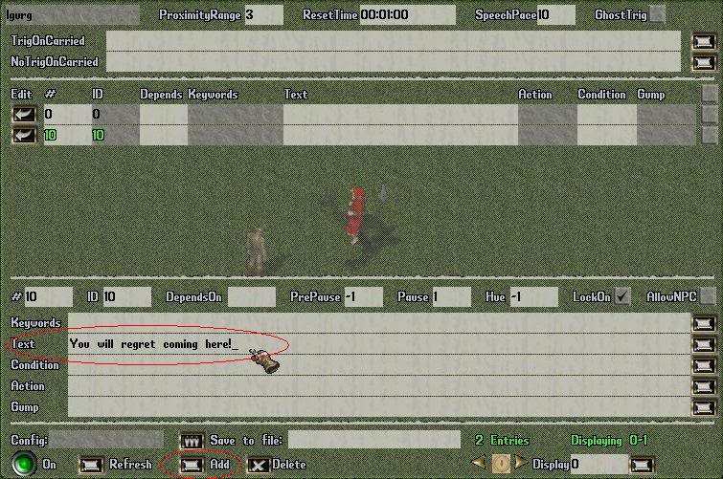  To configure the entry to be activated by nearby player movement alone, set the DependsOn field to -1. This means that the entry doesnt "depend on" any other entry having been just activated.  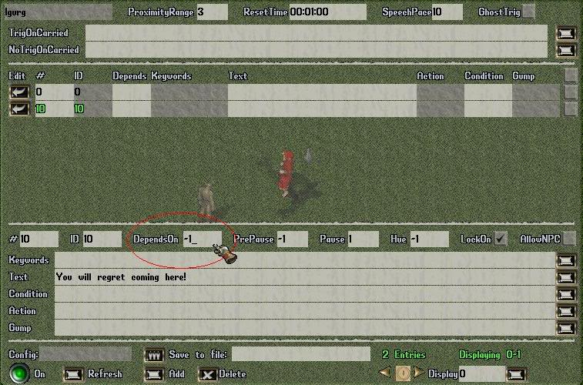  To set the amount of time that has to pass before the npc dialog can be activated again, set the ResetTime field. In this example it is configured for 30 seconds.  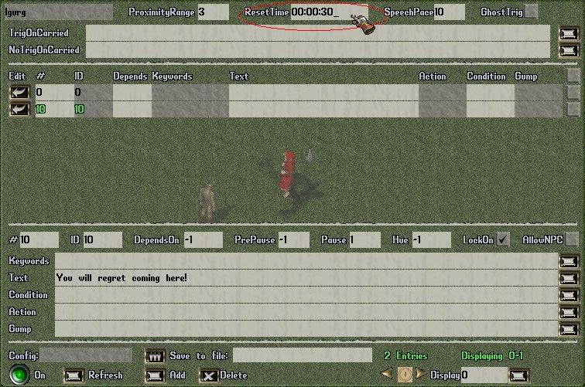  To save the configuration to a file that can be loaded back onto that npc or any other npc, enter in the name of the .npc file and press the Save button.  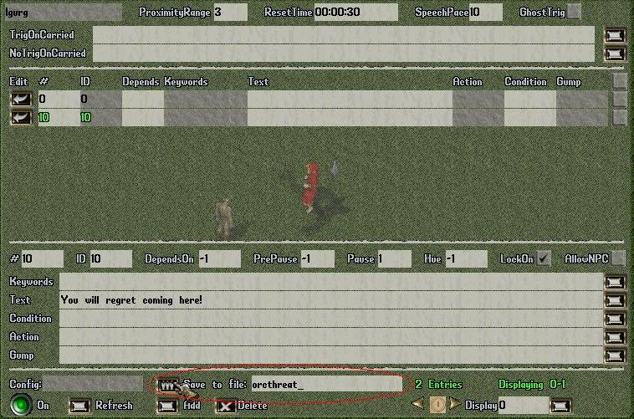  To test the dialog configuration, change your AccessLevel to player (I use the staff cloak for this purpose), and move close to the npc.  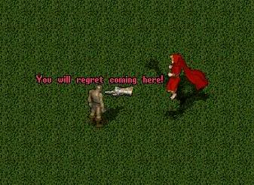  To add a second dialog entry that can also be movement activated, open up the [xmledit gump again using the [xmledit command and targeting the orc, and press the Add button.  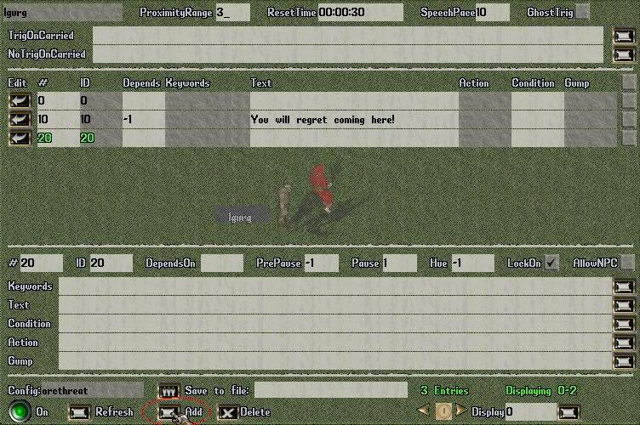  Then enter in another phrase into the Text field and set the DependsOn field to -1. Now when a player comes in range, the entry activated will be randomly selected from these two possible entries and the orc will say one of these phrases every 30 seconds while there are players within the specified proximity range (3 tiles).  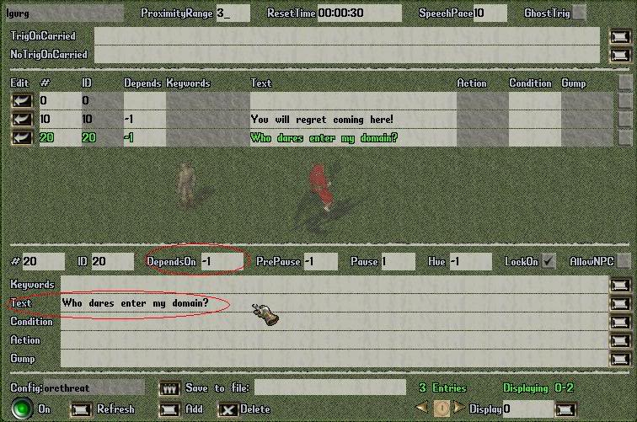  To link together multiple dialog entries so that they follow one after another, set the DependsOn field to the entry ID that you want to precede it.  For example, adding another entry that "depends on" entry 20, will cause that entry to be activated after entry 20. The delay between activating the entries can be specified in the PrePause field in seconds. The default PrePause value of -1 will automatically calculate the delay based upon the length of the text.  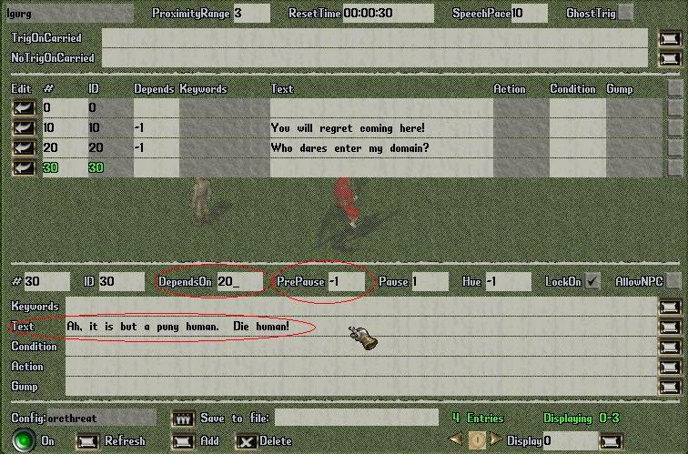  So now when the orc says "Who dares enter my domain?", it will be followed by "Ah, it is but a puny human. Die human!"  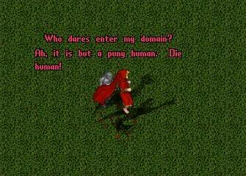  To add an entry that will only be activated if the player says a keyword, add another entry with the Add button, set the Text that you want to be said, and enter in a list of keywords into the Keyword field. If any of the keywords in the list is spoken, the entry will be activated. In this case the DependsOn field is also set to 30 which means that the entry will only be activated if one of the keywords is spoken after entry 30 is activated.  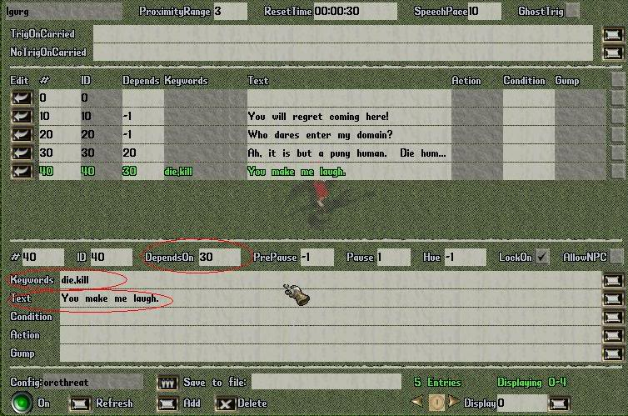  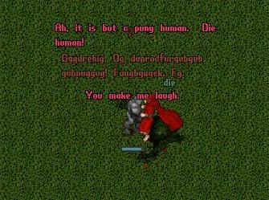  To save all of these edits back to an .npc file, enter in the npc filename such as OrcThreat, and press the Save button again. The configuration can then be loaded onto any npc at a later time using the approaches described at the beginning of this document.  --------------------  

Mage-Solitaire | Posted: January 01, 2006 04:15 pm
  Member  Group: Members  Posts: 27  Member No.: 14  Joined: January 01, 2006 | Utiliser XmlDialogs pour créer des npcs parlant  XmlDialog est un attachement qui est utilisé pour ajouter des possibilités de dialogue interactifs à n'importe quel objet de type npc: talkingnpc, questnpc, etc utilisent ce systeme.  Pour spawner un objet avec un attachement de XmlDialog, vous pouvez employer le mot-clé ATTACH, comme ceci:  orc/ATTACH/xmldialog,npcfile  ceci créera un XmlDialog attachement en utilisant un constructeur qui prend le nom d'un dossier .npc comme argument, et l'attache à l'orc spawné.  Note, vous pouvez attacher XmlDialog à n'importe quel objet, pas seulement une créatures.  Qu'est-ce que les TalkingBaseCreatures, TalkingBaseVendors, et TalkingBaseEscortables?  Les mobiles "talking" sont comme les mobiles classiques, avec les avantages suivant:  1) elles ont l'option "talk" 'dans leurs menus contextuels qui permet le déclenchement des interactions en cliquant sur le npc et en choisissant l'option "talk".  En remplissant la valeur de "TalkText" sur le npc, ce texte sera traité par le npc de recherche comme si le joueur l'avait dit. Même si ceci est permis, la parole peut encore être employée pour lancer des interactions, de sorte qu'un joueur disant le même texte au lieu de choisir l'option de menu de contexte commence l'interaction de la même manière, ceci fournit juste une autre alternative à la parole.  2) elles soutiennent également l'affichage des effets visuels pouvant etre employés pour les identifier en tant que npcs interactifs. Les propriétés d'EItemID, d'EHue, d'EOffset, et d'EDuration définissent l'efet de l'objet, la couleur, l'emplacement de xyz, et la durée d'effet. Le réglage d'EItemID à zéro neutralisera ce dispositif.  Regardez l'exemple de questhighlight.xml dans les xmlextras pour voir divers variations aux npc.  3) ils vous permettent de charger des configurations de XmlDialog en configurant les propriétés de ConfigFile et de LoadConfig. Ceci est souvent employé comme alternative au mot-clé ATTACH lors du spawn (Cela ne fait en réalité aucune différence l'utilisation de l'un ou de l'autre).  4) ils vous permettent de configurer les valeurs d'attachement de XmlDialog en plaçant les mêmes valeurs directement sur la créature.  Il est peu probable que vous l'utilisiez, la méthode la plus simple etant de configurer XmlDialogs avec [xmledit command.  Qu'est-ce qu'un XmlQuestNpc?  Les XmlQuestNpcs sont des TalkingBaseCreatures a qui l'ont a donné forme humaine et peuvent donc etre directement spawné. Ils peuvent être construits avec une valeur de genre (1=female, 0=male) qui ressemblerait à ceci dans un spawn de xmlquestnpc  xmlquestnpc,0  Exemple de npc de parler:  Mettez le dossier de travelagent.npc dans un dossier appelée XmlQuestNPC dans votre dossier principale de RunUO. Vous pouvez la trouver incluse dans le paquet de xmlextras de xmlspawner2.  Créez ensuite un spawner et ajoutez ceci comme entrée  xmlquestnpc/ATTACH/xmldialog,travelagent  ou vous pouvez la faire de cette façon (vous verrez souvent les exemples qui installer des talkingnpc comme ceci)  xmlquestnpc/configfile/travelagent/loadconfig/true  cela fera exactement la même chose. C'est juste une autre manière d'obtenir le npc pour charger une configuration de XmlDialog à partir d'un fichier .npc.  Commencez alors à parler... (assurez-vous que vous êtes un joueur pour le faire sinon vous n'obtiendrez aucune réponse. Vous pouvez employer le StaffCloak pour commuter rapidement à l'accesslevel de joueur pour vos test).  Créer vos propres dialogues  Pour créer votre propre dialogue dans un attachement XmlDialog, vous pouvez employer  [xmledit  puis cibler n'importe quel objet qui a un attachement XmlDialog déjà dessus. Si l'objet n'a pas d'attachement XmlDialog, vous serez incités à en ajouter un neuf.

Rocko | Posted: September 10, 2006 08:03 pm
Advanced Member  Group: Members  Posts: 30  Member No.: 258  Joined: August 11, 2006 | I got a question, how do I use xmledit to make it so that keyword trigger dialog does not depends on other lines? that is, in this example, how do I make it so line 40 does not depends on line 30? I entered in the "Depend on" field a value of -1, but it didnt get triggered by my saying the keyword... any suggestion? Thanks.

ArteGordon | Posted: September 13, 2006 09:48 am
God of XMLSpawner  Group: Admin  Posts: 2,899  Member No.: 2  Joined: December 26, 2005 | what is it that you are trying to do?  The way the dialog system works is that all entries are a part of a dialog tree. You can set the root of the tree with spontaneous banter entries that dont depend on anything except nearby movement (DependsOn = -1), but once you start the conversation, then you must follow the tree structure.  The tree structure is very flexible, so it does not have to branch in a specific pattern. I doubt that you have something that cannot be fit into such a tree.  If you want to have an entry that can be reached from more than one of the branches, just give it multiple DependsOn references  DependsOn = 20,30,40,etc.  --------------------

Rocko | Posted: September 13, 2006 06:08 pm
Advanced Member  Group: Members  Posts: 30  Member No.: 258  Joined: August 11, 2006 | Sorry if I didn't explain clear enough. What I am trying to achieve is the target NPC will always respond to my keyword say "name" with "My name is GodFood, Sir, and how are you today?", regardless of other conditions. So it's a root, but instead of randomly triggered by a player in proximity, it is triggered only by a specific keyword.  Thank you!
  QUOTE (ArteGordon @ September 13, 2006 09:48 am)
  what is it that you are trying to do?
  The way the dialog system works is that all entries are a part of a dialog tree. You can set the root of the tree with spontaneous banter entries that dont depend on anything except nearby movement (DependsOn = -1), but once you start the conversation, then you must follow the tree structure.
  The tree structure is very flexible, so it does not have to branch in a specific pattern. I doubt that you have something that cannot be fit into such a tree.
  If you want to have an entry that can be reached from more than one of the branches, just give it multiple DependsOn references
  DependsOn = 20,30,40,etc.

ArteGordon | Posted: September 13, 2006 07:34 pm
God of XMLSpawner  Group: Admin  Posts: 2,899  Member No.: 2  Joined: December 26, 2005 | You should be able to accomplish this by adding another XmlDialog attachment that just responds to your keyword. It would behave like a separate independent dialog tree.  One problem with this is that [xmledit doesnt support multiple dialogs on a target, so you would have to create them separately, save them to .npc files, and then you could spawn an npc like  xmlquestnpc/ATTACH/<xmldialog,npcfile1/name/dialog1>/ATTACH/<xmldialog,npcfile2/name/dialog2>  where the names 'dialog1' and 'dialog2' give the two xmldialog attachments different names so that they can coexist on the same npc, and 'npcfile1' and 'npcfile2' are the names of the .npc files that were already prepared.  I havent actually tested this out, but it should work.  (edit)  I think that I may have read too much into your question.  If all you wanted to do was to have an npc respond to a keyword without any other entry having been activated before it, just set the DependsOn to zero and set the keyword to whatever you want.  When an XmlDialog is idle, then the default state is set to zero so that is what you can assign to DependsOn when you want it to depend on no prior state or player movement.  --------------------

Rocko | Posted: September 14, 2006 05:05 am
Advanced Member  Group: Members  Posts: 30  Member No.: 258  Joined: August 11, 2006 | The way you suggested works perfectly the way I wanted! Thanks Arte.

Rocko | Posted: September 14, 2006 05:53 pm
Advanced Member  Group: Members  Posts: 30  Member No.: 258  Joined: August 11, 2006 | Yes that was what I wanted to do, sorry I must have stated the question pretty ambiguously.  Now I got the DependsOn ZERO part, but another issue is it seems if I have all entries in one xmldialog, I will not be able to apply different reset timer do I? Say I want a dialog tree like the one you showed in this example to be triggered by player movement but will mute for 30sec before it can be triggered again, since i dont want the NPC to spam the screen when player keep moving around. Now if I add an entry that dependsOn Zero and triggered by a keyword, I wouldn't be able to have player trigger it at any time, because the 30sec is applied to all entries, am I understanding it correctly?  The way you suggested, attach two different xmldialogs, allow me to set different reset timer. Say a towncrier will yell "welcome to my town." every 30 secs given a player moves around; then he will reply "no news today" at any time if someone speaks "news". One inconvenience is I can not xmledit it if I have an NPC loaded with multiple xmldialogs. I have to load only one, edit it, save it, then repeat for the other. Then once I am happy, load all. Would be nice if I could apply different reset timer for different entries in the same xmldialog.
  QUOTE
  I think that I may have read too much into your question.
  If all you wanted to do was to have an npc respond to a keyword without any other entry having been activated before it, just set the DependsOn to zero and set the keyword to whatever you want.
  When an XmlDialog is idle, then the default state is set to zero so that is what you can assign to DependsOn when you want it to depend on no prior state or player movement.

ArteGordon | Posted: September 14, 2006 06:12 pm
God of XMLSpawner  Group: Admin  Posts: 2,899  Member No.: 2  Joined: December 26, 2005 | The idea of having entry-specific reset times has come up before. It will probably be added at some point.  To set up what you describe, just set up your "welcome to my town" entry with DependsOn of -1, and then set up your "news" keyword entry to DependOn on the "welcome to my town" entry.  It will spam the welcome every 30 seconds, and if anyone says the keyword before it resets, then it will activate the news entry.  The only drawback to this is that it will take 30 seconds after getting news for the dialog to reset so that it will respond to the "news" keyword from someone else.  You could try something like this to get around that.  Entry 10: DependsOn = -1; Text="welcome to my town"  Entry 20: DependsOn = 10,30 ; Keyword = "news"; Text="whatever"; LockOn = false  Entry 30: DependsOn = 20 ; Keyword = "news"; Text = "whatever" ; LockOn = false  Having entries 20 and 30 depend on each other (circular branching) means that after getting news, the tree would always have a branch to another "news" entry, so you could activate it immediately without having to wait for it to reset. By unchecking the 'LockOn' box you allow the dialog to respond to anyone, not just the player that first activated it.  --------------------

Rocko | Posted: September 14, 2006 06:33 pm
Advanced Member  Group: Members  Posts: 30  Member No.: 258  Joined: August 11, 2006 | The logic used here seems perfectly fine with me, though it takes some serious thinking to come up with something like this! Kudos to the master.
  QUOTE (ArteGordon @ September 14, 2006 06:12 pm)
  Entry 10: DependsOn = -1; Text="welcome to my town"
  Entry 20: DependsOn = 10,30 ; Keyword = "news"; Text="whatever"; LockOn = false
  Entry 30: DependsOn = 20 ; Keyword = "news"; Text = "whatever" ; LockOn = false

Foruno | Posted: February 09, 2007 06:18 am
Member  Group: Members  Posts: 25  Member No.: 335  Joined: November 08, 2006 | Spanish version of How do I - Make talking npcs here  --------------------  

riverman | Posted: February 09, 2007 04:56 pm
Member  Group: Members  Posts: 10  Member No.: 384  Joined: January 17, 2007 | Arte, i must admit im only up to page 38 in runuo forums, and i have searched here, with no success, can you help please.  this is the idee, a player walks up to a npc, and says hi, in responce the npc askes him if he want to enter the place, the player agrees and the npc says it will cost 1000 gold.  sequentiqal depending on the previous comment.  now up to that i got, but now i have to drag the gold onto the npc and it needs to respond by giving me a ticket (that will teleport me back here when i cant manage- like an escape) and activate the entrance teleporter.  could you advise pls, im a little stumped here.

ArteGordon | Posted: February 09, 2007 05:04 pm
God of XMLSpawner  Group: Admin  Posts: 2,899  Member No.: 2  Joined: December 26, 2005 | dragging and dropping onto an npc will only work if the player has a questholder and the item being dropped satisfies a GIVE quest objective.  In a dialog, you will need to TAKE the gold.  I suppose that during your dialog you could also just give them a questholder with a simple GIVE quest objective and your ticket as the reward.  --------------------

HellRazor | Posted: February 13, 2007 08:33 am
Advanced Member  Group: Members  Posts: 65  Member No.: 315  Joined: October 14, 2006 | I don't know if this is possible, but if not, perhaps a recommended feature.  Is it possible to have the NPC name all of the keywords that the player can use at that point in time?  This would be nice since a player can get lost in the tree, or forget the exact keywords.  Also, how long does it take an NPC to "reset" its dialouge back to its default state due to inactivity? And what if more than one player is conversing with the NPC at the same time?

ArteGordon | Posted: February 13, 2007 01:46 pm
God of XMLSpawner  Group: Admin  Posts: 2,899  Member No.: 2  Joined: December 26, 2005 | "Is it possible to have the NPC name all of the keywords that the player can use at that point in time?"  interesting idea. Many times you want the keywords to remain hidden, but perhaps adding an option for the designer to specify "hints" for an entry which could include a list of keywords.  "Also, how long does it take an NPC to "reset" its dialouge back to its default state due to inactivity? And what if more than one player is conversing with the NPC at the same time? "  The reset time is specified at the top of the [xmledit gump. By default it is 1 minute, but you can set it to whatever you like.  You can also manually force resetting  from xmlspawner2.txt  and by default, the first player to initiate dialog is the only one that the npc will respond to until it resets. This can be changed by toggling the LockConversation box for individual dialog entries. By clearing this setting for a dialog entry it allows anyone to trigger the entry.  --------------------
  QUOTE
  - a small change to the XmlDialog attachment that allows it to be reset by setting the DoReset property via an Action field in XmlDialog entries (thanks to Vladimir for the idea). This allows the use of an action such as
  SETONTHIS/doreset/true
  to allow the xmldialog to become immediately available for reactivation without having to wait for it to timeout from the last player.
  QUOTE
  - added the LockConversation property to to talking NPCs allowing you to specify whether a conversation with the NPC should be locked to the first player to interact with it (LockConversation=true) until the conversation resets, or whether you want it to be able to interact with anyone at any time (LockConversation=false). This also allows a new conversationalist to be established in mid-conversation when it is disabled in a single entry. This is true by default.

HellRazor | Posted: February 15, 2007 09:46 am
Advanced Member  Group: Members  Posts: 65  Member No.: 315  Joined: October 14, 2006 | Thanks Arte!  One other question - is it possible to specify the color of text? For instance, if I wanted to highlight the key words in a conversation by coloring them red.

ArteGordon | Posted: February 15, 2007 12:18 pm
God of XMLSpawner  Group: Admin  Posts: 2,899  Member No.: 2  Joined: December 26, 2005 | I dont believe that you can hue individual words in the unicode text that is used for speech, so text that is displayed overhead (the Text field) would all be the hue specified by the speech Hue setting for the entry.  On the otherhand, gumps use html for their text so you can modify the hue and style of text displayed in gumps by using html tags. For example adding this to the Gump field  GUMP,test,0/this is <u><basefont color=#00ff00>underlined colored text</basefont></u> in the middle of a sentence  would display a gump with the specified text colored in green and underlined.  --------------------

Erica | Posted: April 11, 2007 06:59 pm
Senior Member  Group: Members  Posts: 326  Member No.: 185  Joined: June 28, 2006 | Question since i got world spawned already using neruns file with your xml spawners how would i go about fixing all those npc spawners only to be set for them to talk words like osi..  --------------------
  QUOTE (ArteGordon @ December 31, 2005 03:47 am)
  Using XmlDialogs to create talking npcs
  XmlDialog is an attachment that is used to add interactive dialog capabilities to any object including npcs. All of the talking npcs, quest npcs, etc. use this system.
  To spawn an object with an XmlDialog attachment, you can use the ATTACH keyword like this:
  orc/ATTACH/xmldialog,npcfile
  This creates an XmlDialog attachment using a constructor that takes the name of a .npc file as an argument, and attaches it to the spawned orc.
  Note, you can attach XmlDialogs to any object, not just creatures.
  What are TalkingBaseCreatures, TalkingBaseVendors, and TalkingBaseEscortables?
  The Talking classes are like the regular classes with the following extra features:
  1) They have support for the 'Talk' option in their context menus that allows initiation of interactions by clicking the npc and selecting the "Talk" option.
  By Setting the TalkText property on the npc, that text will be processed by the quest npc as though the player had spoken it. Even if this is enabled, speech can still be used to initiate interactions, so that a player saying the same text instead of selecting the context menu option will start the interaction in the same way, this just provides another alternative to speech.
  2) They also support the display of overhead effects that can be used to identify them as interactive npcs.
  The EItemID, EHue, EOffset, and EDuration properties define the effect item, hue, xyz offset, and effect duration. Setting EItemID to zero will disable this feature.
  Look at the questhighlight.xml example in xmlextras to see various npc highlighting schemes.
  3) They allow you to load up XmlDialog configurations by setting the ConfigFile and LoadConfig properties. This is often used as an alternative to using the ATTACH keyword when spawning (it doesnt make any actual difference).
  4) They allow you to configure XmlDialog attachment properties by setting the same properties directly on the creature.
  It is unlikely that you would ever need to do this, since the preferred method of configuring XmlDialogs is with the [xmledit command.
  What is an XmlQuestNpc?
  XmlQuestNpcs are just TalkingBaseCreatures that are given human form and can be directly spawned.
  They can be constructed with a gender argument (1=female, 0=male) which would look like this in a spawn entry
  xmlquestnpc,0
  to spawn a male npc.
  Talking npc example:
  Put the travelagent.npc file in a folder named XmlQuestNPC in your main RunUO folder. You can find it included in the xmlextras package of xmlspawner2.
  Then create a spawner and add this as a spawn entry
  xmlquestnpc/ATTACH/xmldialog,travelagent
  or you can do it this way (you will often see examples that set up talking npcs like this)
  xmlquestnpc/configfile/travelagent/loadconfig/true
  This will do exactly the same thing. It is just another way of getting the npc to load up an XmlDialog configuration from a .npc file.
  Then start talking... (make sure you are a player when doing this otherwise you will not get any response. You can use the StaffCloak to quickly switch to player accesslevel for testing).
  Creating your own dialog
  To create your own dialog in an XmlDialog attachment, you would use the
  [xmledit
  command, and target any object that has an XmlDialog attachment already on it.
  If the object does not have an XmlDialog attachment, you will be prompted to add a new one.
  Once you have added the XmlDialog, you can add and edit the dialog entries.
  To add a new entry, press the Add button in the [xmledit gump.
  To enter in the text that you want the npc to speak edit the Text field.
  To configure the entry to be activated by nearby player movement alone, set the DependsOn field to -1. This means that the entry doesnt "depend on" any other entry having been just activated.
  To set the amount of time that has to pass before the npc dialog can be activated again, set the ResetTime field. In this example it is configured for 30 seconds.
  To save the configuration to a file that can be loaded back onto that npc or any other npc, enter in the name of the .npc file and press the Save button.
  To test the dialog configuration, change your AccessLevel to player (I use the staff cloak for this purpose), and move close to the npc.
  To add a second dialog entry that can also be movement activated, open up the [xmledit gump again using the [xmledit command and targeting the orc, and press the Add button.
  Then enter in another phrase into the Text field and set the DependsOn field to -1. Now when a player comes in range, the entry activated will be randomly selected from these two possible entries and the orc will say one of these phrases every 30 seconds while there are players within the specified proximity range (3 tiles).
  To link together multiple dialog entries so that they follow one after another, set the DependsOn field to the entry ID that you want to precede it.
  For example, adding another entry that "depends on" entry 20, will cause that entry to be activated after entry 20. The delay between activating the entries can be specified in the PrePause field in seconds. The default PrePause value of -1 will automatically calculate the delay based upon the length of the text.
  So now when the orc says "Who dares enter my domain?", it will be followed by "Ah, it is but a puny human. Die human!"
  To add an entry that will only be activated if the player says a keyword, add another entry with the Add button, set the Text that you want to be said, and enter in a list of keywords into the Keyword field. If any of the keywords in the list is spoken, the entry will be activated. In this case the DependsOn field is also set to 30 which means that the entry will only be activated if one of the keywords is spoken after entry 30 is activated.
  To save all of these edits back to an .npc file, enter in the npc filename such as OrcThreat, and press the Save button again. The configuration can then be loaded onto any npc at a later time using the approaches described at the beginning of this document.

ArteGordon | Posted: April 12, 2007 04:36 pm
God of XMLSpawner  Group: Admin  Posts: 2,899  Member No.: 2  Joined: December 26, 2005 | if you want to spawn vendors that have specific dialog attachment, you can change their spawner entries from something like  jeweler  to  jeweler/ATTACH/xmldialog,jewelerdialog  where you have your .npc file named jewelerdialog.npc placed into the default .npc folder (XmlQuestNPC)  You would have to edit the individual spawner entries to do this. To do it on a large scale you could also save your vendor spawners out to an xml file (for example using [xmlfind), and then do global string search/replace, and reload the xml file.  You could also edit the vendor scripts to automatically add the dialog attachments by adding something like this into their constructors  XmlAttach.AttachTo(this, new XmlDialog("jewelerdialog"));  You can take a look at the jeweler.npc file in xmlextras for some ideas.  --------------------

Rocko | Posted: April 24, 2007 10:27 pm
Advanced Member  Group: Members  Posts: 30  Member No.: 258  Joined: August 11, 2006 | Is there anyway to make it so only the triggering player hear the talk?

ArteGordon | Posted: April 25, 2007 10:43 am
God of XMLSpawner  Group: Admin  Posts: 2,899  Member No.: 2  Joined: December 26, 2005 | you could have the npc whisper by setting the speechstyle property. It isnt strictly private but close  --------------------
  QUOTE (Rocko @ April 24, 2007 05:27 pm)
  Is there anyway to make it so only the triggering player hear the talk?
  QUOTE
  - added the SpeechStyle property to talking NPCs that allows you assign a MessageType to a speech entry like Regular (the default), Yell, Whisper, Emote.

Rocko | Posted: April 25, 2007 05:40 pm
Advanced Member  Group: Members  Posts: 30  Member No.: 258  Joined: August 11, 2006 | Thanks Arte, that sounds a great addition.  I have another question, I know it is not in the current release, but just want some suggestions how I should go about do it, or find an alternative to solve the problem I am facing?  Is there anyway to allow a player to use a keyword to turn off the speech of a particular NPC to himself only? We have a starting area and as we add more talking NPCs with tutorials information, the screen soon gets very crowded when someone runs by. It would be nice if say player A decided to selectively hear only from certain NPCs by disable the speech from the rest, of course, just to player A. It wouldn't affect other players. If technically too much hassle, I can consider spead them out, though the starting area has always been the most visited place and easiest to broadcast any information.  Thanks again!
  QUOTE (ArteGordon @ April 25, 2007 10:43 am)
  you could have the npc whisper by setting the speechstyle property. It isnt strictly private but close.

ArteGordon | Posted: April 27, 2007 12:56 pm
God of XMLSpawner  Group: Admin  Posts: 2,899  Member No.: 2  Joined: December 26, 2005 | good idea. There is not currently support for private overhead messages, but it would be an easy option to add to xmldialog entries.  That would restrict the display of overhead text to the triggering player. I'll get it into the next release.  --------------------

Erica | Posted: October 28, 2007 03:18 am
Senior Member  Group: Members  Posts: 326  Member No.: 185  Joined: June 28, 2006 | i only can target the npc character and it works but was trying to see of targeting the spawner from those towns so it can speak if got 4 npc on spawners but that didnt work.  --------------------

ArteGordon | Posted: October 28, 2007 11:27 am
God of XMLSpawner  Group: Admin  Posts: 2,899  Member No.: 2  Joined: December 26, 2005 | you would either modify the spawner entry for each of them like this  tailor/ATTACH/xmldialog,npcfile  where you would have set up the npcfile earlier. You can do that by just editing an xmldialog on an npc using xmledit and then Saving it to File.  Or, if you wanted to script this into your npcs, just add something like this into their constructor  XmlAttach.AttachTo(this, new XmlDialog(npcfile));  where, again, you have already set up the npc file that you want to have used.  So making the following mod to Jeweler.cs will cause all jewelers to generate dialog according to the file jewelerdialog.npc. No change to their spawner entries is required for this. The next time the npc spawns, they will have dialog.  and you would need to add this to the top of the script  Also note that even if you add it to their scripts, you can still spawn them with individual dialogs as I showed and the spawned dialog will replace the scripted one by default.  I would say that which method you choose depends on how widespread you want the change to be. If you want all npcs to have it, then it is easier to modify their scripts. If you just want a few, then it is easier to modify their spawn entries.  --------------------
  QUOTE
  [Constructable]
  public Jeweler()
  : base("the jeweler")
  {
  SetSkill(SkillName.ItemID, 64.0, 100.0);
  XmlAttach.AttachTo(this, new XmlDialog("jewelerdialog"));
  }
  CODE
  using Server.Engines.XmlSpawner2;

Erica | Posted: October 28, 2007 03:17 pm
Senior Member  Group: Members  Posts: 326  Member No.: 185  Joined: June 28, 2006 | Ok i tryed it by short way with few npc on one spawner and put the cloak on to be regular player but nothing happen they didnt talk heres and image.  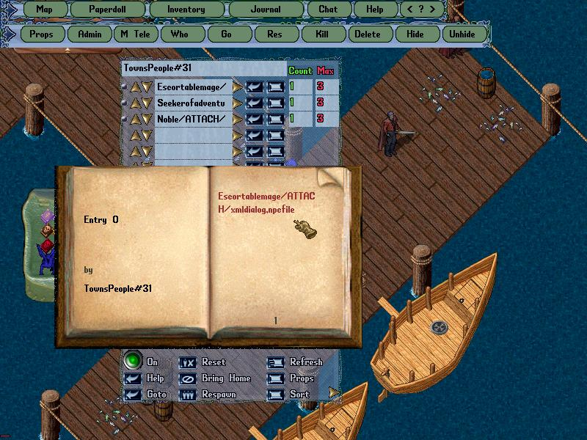  --------------------

ArteGordon | Posted: October 28, 2007 03:35 pm
God of XMLSpawner  Group: Admin  Posts: 2,899  Member No.: 2  Joined: December 26, 2005 | did you create a .npc file named "npcfile"?  Use [xmledit on the npc and edit the entries as you like. Then when you are finished, enter the name of the .npc file into the "Save to File" dialog, and save it.  --------------------

Erica | Posted: October 28, 2007 03:43 pm
Senior Member  Group: Members  Posts: 326  Member No.: 185  Joined: June 28, 2006 | Yes i saved when i open runuo folder theres a file there called npc file. Unless i have to put that file thats in runuo folder and make a folder in there called dialog so not sure whats wrong.  --------------------
  QUOTE (ArteGordon @ October 28, 2007 08:35 am)
  did you create a .npc file named "npcfile"?
  Use [xmledit on the npc and edit the entries as you like. Then when you are finished, enter the name of the .npc file into the "Save to File" dialog, and save it.

ArteGordon | Posted: October 28, 2007 06:31 pm
God of XMLSpawner  Group: Admin  Posts: 2,899  Member No.: 2  Joined: December 26, 2005 | what is the exact name of the file in the RunUO folder? Is it "npcfile.npc" or "npc file.npc"?  Having it in the main RunUO folder is fine. It will find it there. You can also put it into the XMLQuestNPC folder. It will find it in there too.  --------------------

Erica | Posted: October 28, 2007 07:11 pm
Senior Member  Group: Members  Posts: 326  Member No.: 185  Joined: June 28, 2006 | Its npc file.npc so im not sure why isnt it working.  --------------------
  QUOTE (ArteGordon @ October 28, 2007 11:31 am)
  what is the exact name of the file in the RunUO folder? Is it "npcfile.npc" or "npc file.npc"?
  Having it in the main RunUO folder is fine. It will find it there. You can also put it into the XMLQuestNPC folder. It will find it in there too.

ArteGordon | Posted: October 28, 2007 07:52 pm
God of XMLSpawner  Group: Admin  Posts: 2,899  Member No.: 2  Joined: December 26, 2005 | if you have a space in the filename like "npc file", then that is exactly how you need to refer to it when you load it.  tailor/ATTACH/xmldialog,npcfile  is not the same as  tailor/ATTACH/xmldialog,npc file  --------------------

Erica | Posted: October 28, 2007 08:23 pm
Senior Member  Group: Members  Posts: 326  Member No.: 185  Joined: June 28, 2006 | Ok im confused remember i xmledit a xmlspawner thats called TownsPeople #31 as you see on picture above so that spawner is laying there or am i suppose to delete that spawner and if so whats the command to load the one in my runuo folder.  --------------------

ArteGordon | Posted: October 28, 2007 08:42 pm
God of XMLSpawner  Group: Admin  Posts: 2,899  Member No.: 2  Joined: December 26, 2005 | [xmledit is a utility for creating and editing xmldialogs.  Once you create or edit an xmldialog, you have the option to save that information out to a file.  You do that from within the [xmledit gump. Look for the "Save to File" dialog at the bottom of the [xmledit gump.  Once you have saved the xmldialog information out to a file, you can load that file into a spawned npc using a spawner entry like the one you showed.  Escortablemage/ATTACH/xmldialog,npcfile  "npcfile" is the name of the file that you saved earlier.  You do not need to use [xmedit on the spawner.  Once you spawn the npc using the spawn entry above, try use [xmledit on the npc to see the dialog information that has been attached to it.  Then you can modify and save that information using [xmledit on the npc as many times as you like and then just respawn the npc.

